Sha’Necia Holden

ITAI 4373 Fall

L01 Basic real-time simulation using NetLogo

Professor Patricia Mcmanus

### L01 Basic real-time simulation using NetLogo

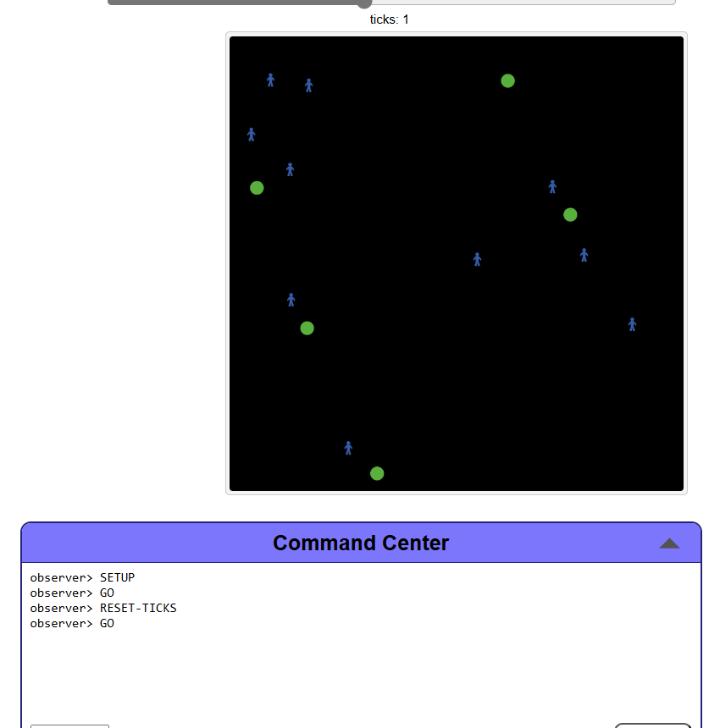

**Reflective Journal**:

* 1. **Learning Outcomes**:
     + Summarize key concepts learned about real-time simulation and AI behaviors

The key concepts that I’ve learned about real-time simulation and AI behaviours were how to plan out the movements and interactions with the people and food source. Everything was quite intricate. Every line had to flow properly that way the code could be read properly when netlogo had to run it. I also had to make sure I set up the interface so that I can activate the commands like “reset”, “setup” and “go”. To reset the simulation , to set up the simulation and start the sim with the “Go” key , I even assigned the hotkey to be “G” so that I watch the simulation move, by pressing G.

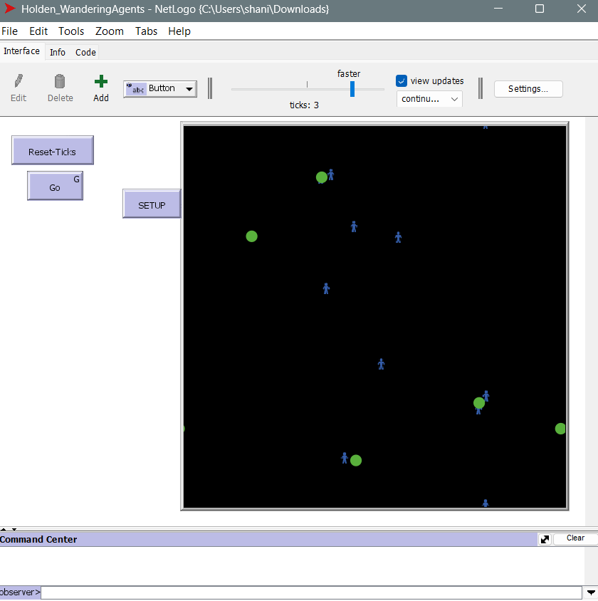

* + - Explain how this lab enhanced your understanding of agent-based modeling. :

This lab enhanced my understanding of agent-based modeling by using netlogo to develop real-time AI simulations that require robust computational skills. We were given an assignment to simulate an environment , where you have the agents and the food source and to interact with each other inside of this virtual environment. The code that we had to set up was defining the variables in the code, stating the correct syntax , and assigning movements so that the people could wander around the virtual environment and consume the food source once they come in contact with it. We had to set the entire simulation up. The code that was originally mashed together, so we as individuals had to input the code in the correct formatting within NetLogo. Agents are already considered a variable, so we had to rename our agents as something else. So I gave the name “persons” and “person”, while the food source could remain the same.

* 1. **Technical Skills**:
     + Describe new skills acquired using NetLogo.

The new skills I’ve acquired while using NetLogo, is patience, I didn’t get frustrated to the point where I gave up, but I was able to fully tackle the assignment while troubleshooting the issues that I was having , such as not being able to call the variable an agent , giving it another name. I realized that our professor wanted us to not rely on the instructions too heavily but also to try things while seeing exactly what works and what doesn’t.

I was able to use a bit of coding despite netlogo having a different format and rules slightly .

* + - Discuss potential real-world applications of these skills.
  1. **Challenges and Solutions**:
     + Identify difficulties encountered during the lab.
     + Explain how you overcame these challenges.

Ooh boy , the challenges. Well in the assignment , the original code we were supposed to input was incorrect. The formatting of the code did NOT translate over to the NetLogo code layout at all. So this assignment was not a quick copy and paste at all. Which is great, I love a challenge but I literally almost pulled my hair out because the command center was very strict with the rules. Certain environments you’re able to put in certain commands so I had to make sure I was in the right environment before inputting the commands.

* 1. **Critical Analysis**:
     + Evaluate strengths and limitations of your simulation model.

Evaluating strengths and limitations of the simulation model, the strengths were able to label the simulation from simple to complex and being a useful tool to be utilized in the future.

Suggest one improvement to make the model more realistic or complex. :

If I had more time, I would play around with the simulation, probably adding predators, and another consumer to see who would be the fittest when it comes to survival , just like real life.

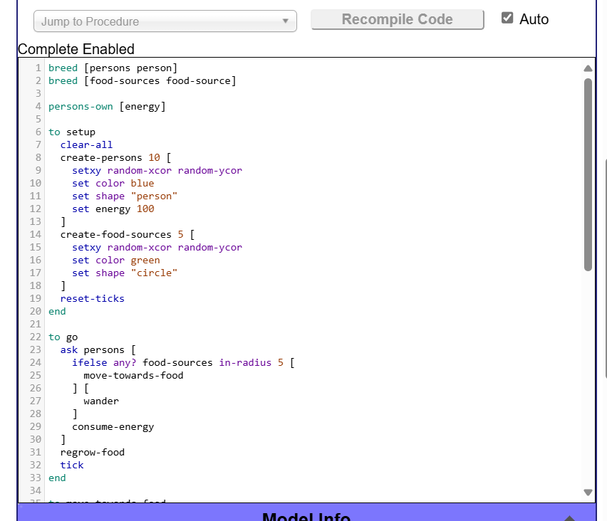

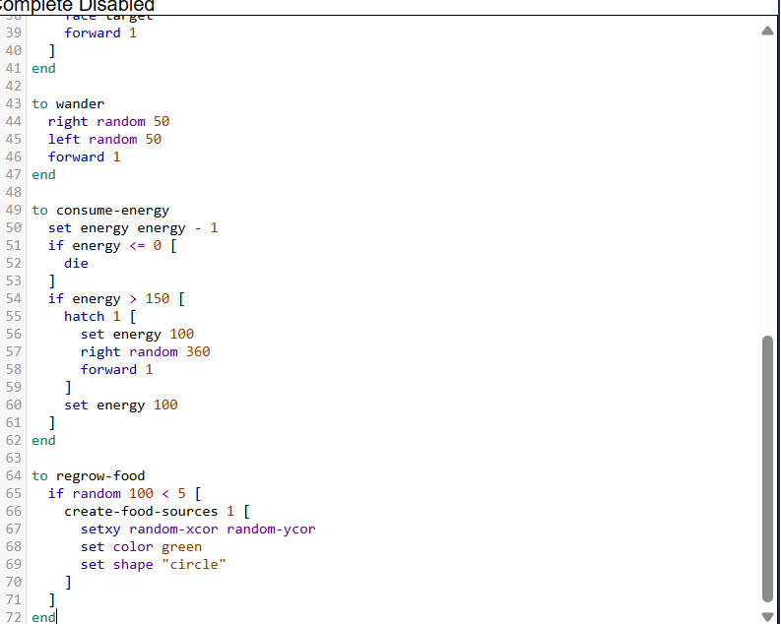

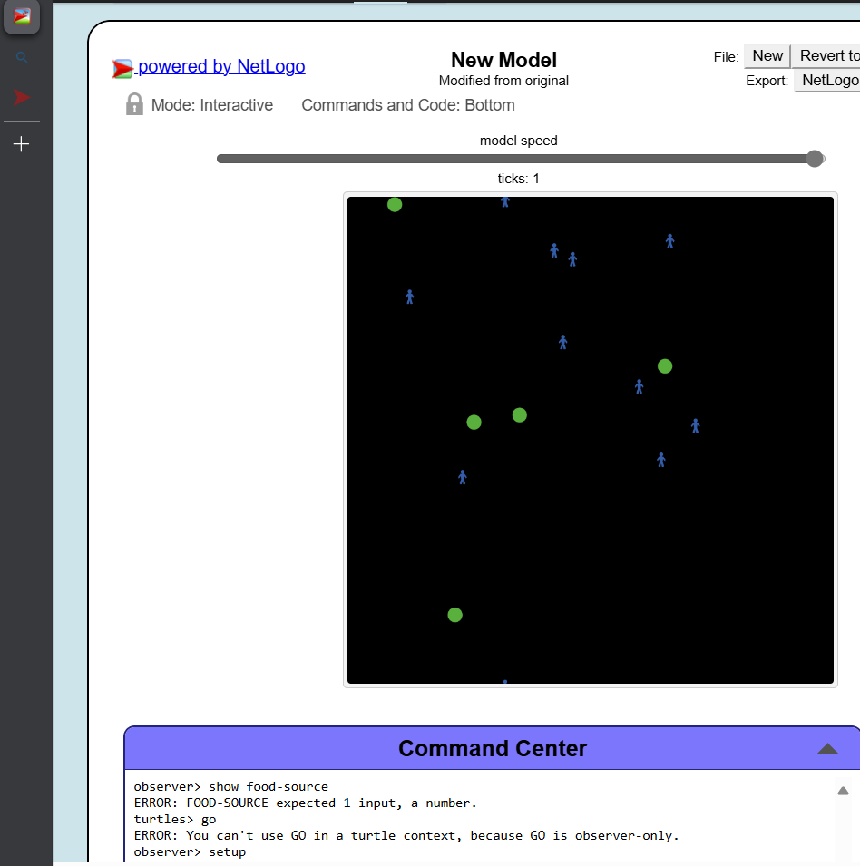

* 1. **Course Connections**:
     + Relate your lab experience to Module 1 lecture concepts.
       - * The experience here and during the lecture concepts perfectly align, simulations and introductions .
     + Identify one new insight about AI behaviors or real-time simulations.

Real insight is actually being able to set the simulator up instead of watching it.

* 1. **Personal Reflection**:
     + Describe how this lab influenced your perception of AI simulations.

It opened the door to seeing how to code a basic simulation and what commands interact with what.

* + - Discuss an aspect of the lab that particularly interested you.

The aspects of the lab that particularly interested me was being able to set up the characteristics of the simulation, assign the variables, watch the code run… AH .. Honestly pretty much the entire project interested me completely.